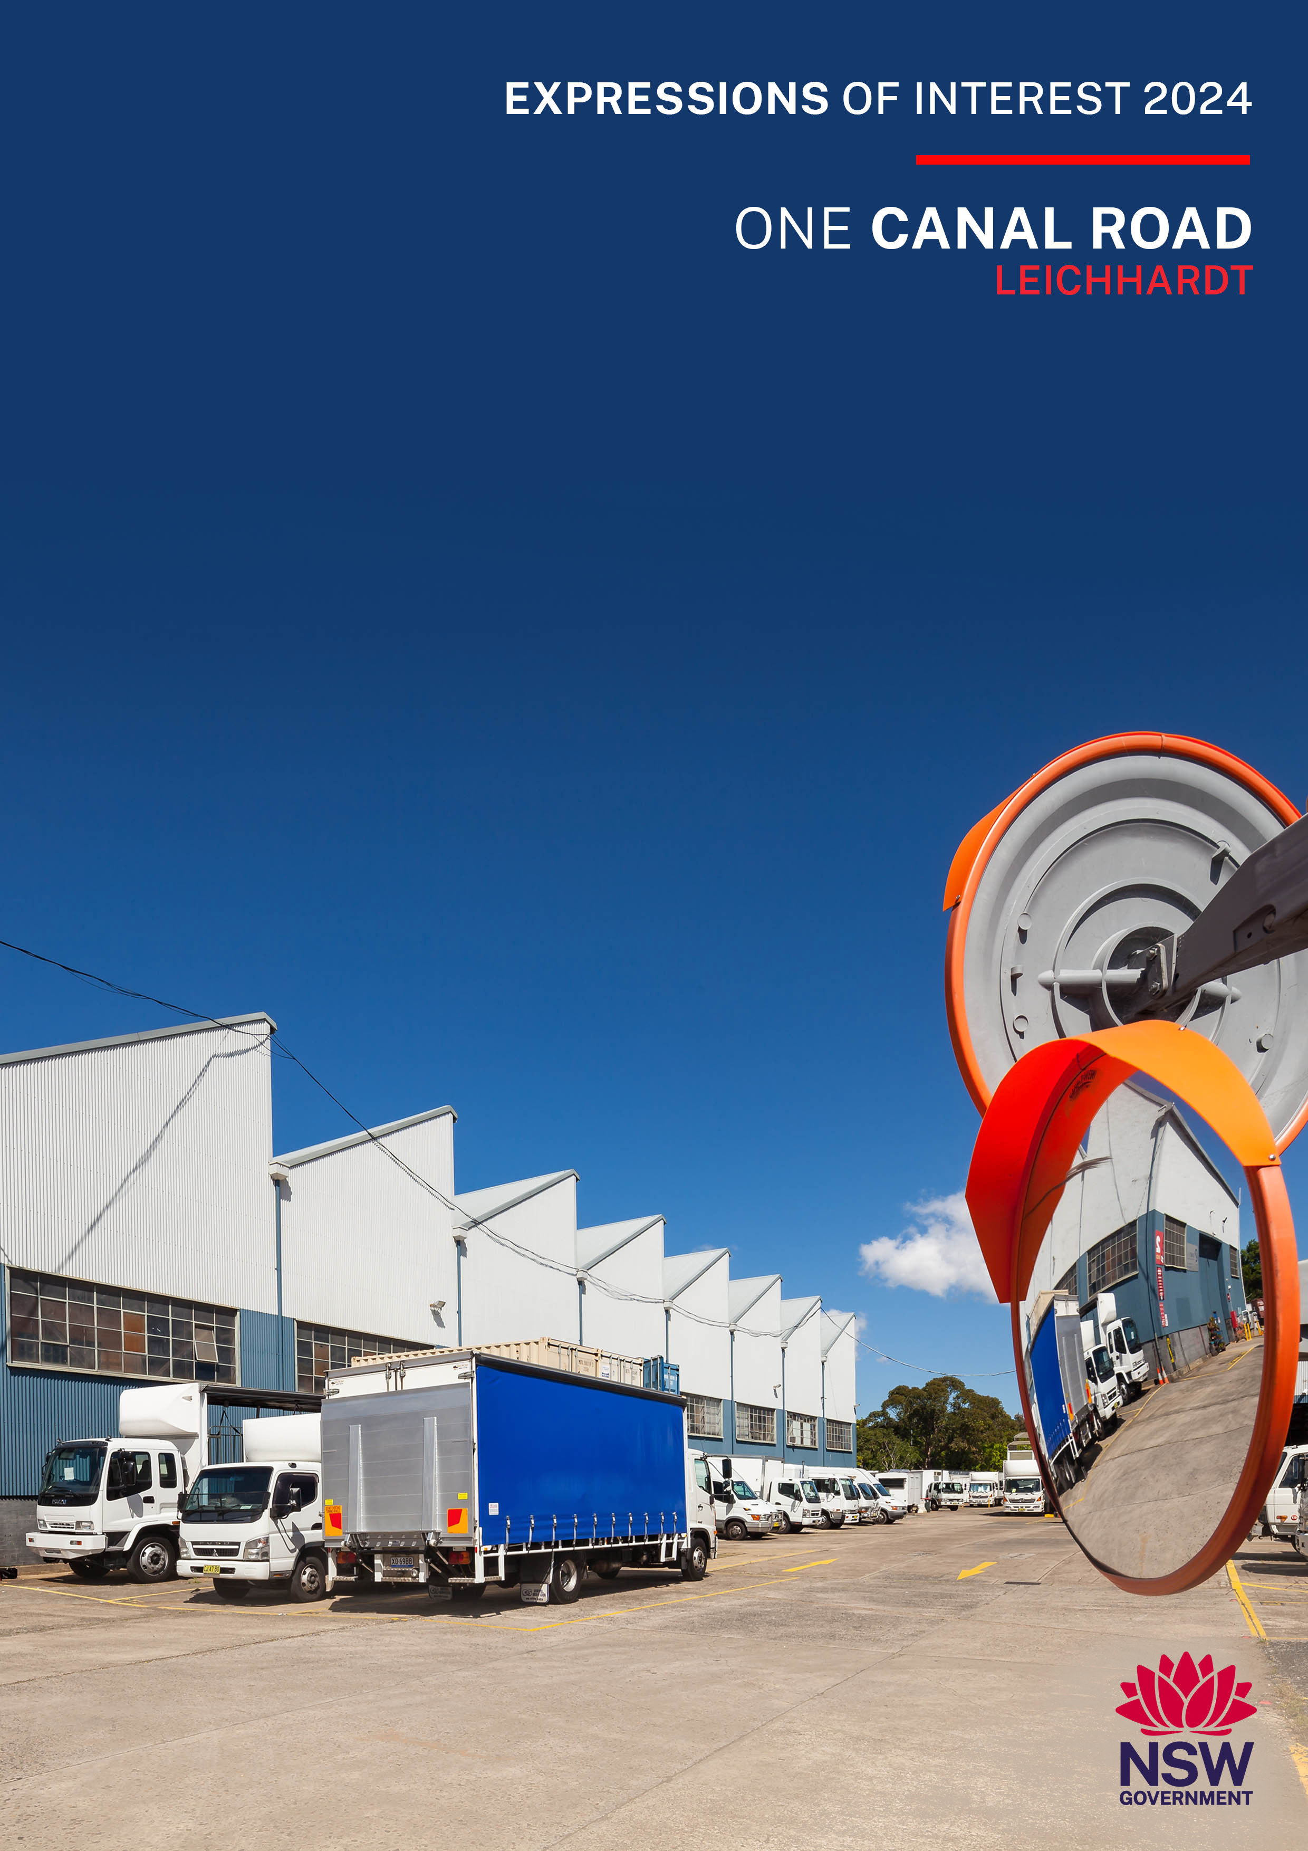

Create NSW acknowledges the Aboriginal people across New South Wales and their continued connection to their lands, waters and culture.
We respect Elders past and present and the roles that Aboriginal people, artists and creatives play in contributing to their culture.

call for Expressions of interest
Create NSW is calling for expressions of interest from eligible screen and arts organisations and commercial businesses to apply for workshop spaces at One Canal Road, Leichhardt. There are one (1) workshop space, and 4 x truck, 4 x van, 8 x container parking available. In applying for this EOI you accept the lease terms and conditions and that a non-negotiable lease agreement based on these terms and conditions will be entered into.

Eoi timeframe
selection process | date
1. Submissions open | 18 October 2024 (3 weeks)
2. Site inspection  Inspection of the spaces in person  is available by appointment only  Please contact Subash Gurram,  Precinct Operations Manager, Create NSW by email for details: Subash.gurram@create.nsw.gov.au | 1:00 pm 24 October 2024
3. Closing date for submissions | 10:00 am 11 November 2024
3. Notify successful applicants | Late November/Early December 2024
4. Notify unsuccessful applicants | Late November/Early December 2024
5. Lease/Licence commencement dates | December 2024 or by negotiation

About CREATE nsw and the
infrastructure support policy
Create NSW

Create NSW is the NSW Government’s arts and cultural driver, which brings together arts, screen and culture functions in an integrated entity, and includes cultural infrastructure.
Create NSW is responsible for furthering Government’s vision for NSW to be known for its bold and exciting arts and culture that engages the community, supports innovation, facilitates economic development, and reflects the state’s rich diversity.
Create NSW invests in the success and future of arts, screen and culture in NSW through infrastructure, funding programs, partnerships and advocacy.
Create NSW is committed to growing, empowering and strengthening the arts, screen and culture sectors in NSW, to embed arts in the everyday and deliver new, innovative and exciting arts and cultural services, infrastructure and experiences for the people of NSW.
Create NSW works to achieve the NSW Government’s strategic objectives to develop and sustain the arts, culture and screen sectors, which are built upon the ambitions of excellence, access and strength, and which reflect and support the diverse communities across NSW.
One means by which Create NSW achieves these objectives is through the management of a property portfolio that provides infrastructure support to arts and cultural organisations and allows them to be co-located with other appropriate organisations.
Further information on Create NSW is available on the Create NSW website www.create.nsw.gov.au

Infrastructure Support Policy

The Create NSW infrastructure support program is a key integrated component of the Government’s program of support to the arts.
Create NSW manages ten properties in and around the Sydney CBD. These have effectively developed as arts and cultural hubs through the clustering of like arts and cultural organisations as tenants. Over 100 organisations are supported in subsidised accommodation.
The Create NSW Infrastructure Support Policy (ISP) guides the operation and management of the infrastructure support program.
The ISP sets out the framework for the allocation of spaces and guidelines for the ongoing operation of the Create NSW property portfolio. The ISP provides for eligible arts and cultural organisations to pay 30% of the current market rent for office and creative space, and 50% of current market rent for storage and workshop spaces, paid monthly in advance. It also provides for support for eligible commercial entities that primarily work in the screen sector.

About One Canal Road
One Canal Road is the largest business precinct in Australia dedicated to serving technicians and artisans in the NSW screen sector, plus theatre and arts. The former public works site from 1913 to 1992 is home to around 50 industry tenants across 19 specialised trades. Create NSW acquired the site in July 2021. Tenants have worked on features films, TV dramas, theatre shows, and TV commercials. The short-term offices and workshops accommodate productions. The precinct is currently home to businesses that specialise in trades such as bespoke costume, shoes and wigs, costume and prop hire, film/tv caterers, special effects, set construction, gaffers, grips, makeup truck manufacture and other businesses that support the screen sector as well as theatre and the arts.

vision for One canal road
“A precinct primarily dedicated to serving the NSW screen sector, as well as theatre and the arts. A hub that supports creativity, specialised trades and services, and productions that support NSW film, television, and theatre.”

eligibility
Applicants must be screen, arts or cultural organisations or businesses located in NSW that align with the vision for One Canal Road.
Applications are invited from:
- Screen, arts or cultural organisations which are not-for-profit, based in NSW, and have an annual turnover of less than $50 million per year.
- Businesses primarily serving the NSW screen sector, or theatre and the arts, who are registered in NSW, have a principal place of business in NSW at the date of the application, and have an annual turnover of less than $50 million per year.

information about the premises
Item | DetailS
Workshop spaces and plans | One (1) workshop space on mezzanine level in Building one, and 4 x truck, 4 x van, 8 x container parking available. Floor Plans of the available spaces are shown at Annexure A.
Fit-out of workshop space | Fit-outs are at Lessee’s cost and responsibility, are subject to Lessor consent, and must comply with relevant laws and standards such as the National Building Code, and WHS and fire requirements. Any consents, certificates, approvals or permits required under legislation or from any authority necessary to enable the works to be lawfully effected must be provided to the Lessor upon request.
Parking | Car parking spaces onsite are allocated per Lessee – subject to the size of the tenancy and availability. Car parking is also available outside the precinct.
Shared Facilities | - Shared amenities  - Truck wash

KEY LEASE terms
Item | DetailS
Lease and Licence term | Sublease for workshop - up to 28 February 2027 with a 1 + 1 year option  Licences for truck/van/containers - up to 28 February 2027 and will have provisions for holdover beyond licence term.
Tenancy Floor Plans | Floor Plans are at Annexure A of this document. Relevant floor plans will form part of the leases/licences granted to successful EOI applicants.
Rent and estimated Outgoings | Rent  Under the Create NSW Infrastructure Support Policy eligible not-for-profit arts and cultural organisations pay 50% of current market rent for workshop space, and eligible commercial entities will pay 70% of the current market rent. Rent is paid monthly in advance and adjusted annually by CPI. The tenancy during holding over is on the same terms as apply during the lease/licence period.  Outgoings  Lease  Lessee pays tenancy outgoings.  After term duration to 28 February 2027, the Lessee will also be required to contribute to the site’s common area outgoings based on the percentage of the area occupied by the Lessee.  Licence  If any holdover after term during to 28 February 2027 the Licensee will be required to contribute to the site’s common area outgoings based on the percentage of the area occupied by the Licensee.
Space details, rent, and security deposit | A security deposit in an amount of two-month’s rent will be required to be lodged by successful EOI proponents.
  Building | Space/Unit  Number | Lettable Area  m2 | Annual Rent $  Excluding GST
  1 workshop | 1.27 | 63.5 | $8,446
  Truck Parking | T70 | 12m L x 3.10m W | $6,470.64
  Truck Parking | T86 | 14m L x 3.90m W | $6,470.64
  Truck Parking | T89 | 11m L x 2.55m W | $6,470.64
  Truck Parking | T90 | 11m L x 2.55m W | $6,470.64
  Van Parking | V40 | 7m L x 2.4m W | $4,053
  Van Parking | V41 | 7m L x 2.4m W | $4,053
  Van Parking | V44 | 7m L x 2.4m W | $4,053
  Van Parking | V45 | 7m L x 2.4m W | $4,053
  Containers x 8 | C07, C16, C20, C21, C22, C28, C34, C40 | 20 ft container dimensions | $2,773 per container space
Repair, maintenance and replacement responsibilities | Lease  Responsibility for repair, maintenance and replacement is split between the Lessor and Lessee. The Lessor is responsible mainly for building fabric and the Lessee for fixtures and fittings and tenancy items.  Details of the repair, maintenance and replacement responsibilities are shown in Annexure B.  Licence  The Licensee is responsible to ensure the Licensed Area is maintained in its condition at commencement of the Licence and is kept in good safe repair and to make good any loss, damage or degradation to the Licensed Area and remediate any damage or contamination to the Licensed Area.
Work Health and Safety | The Lessee/Licensee will be required to comply with all relevant provisions of the Work Health and Safety Act 2011.
Law | The Lessee/Licensee will be required to comply with all applicable Law.
Insurance | The Lessee/Licensee will be required to provide evidence of current public liability insurance in an amount of not less than $20m.
Indemnity | Leases/Licences granted to successful EOI applicants will include an Indemnity clause:  The Lessee/Licensee uses the Leased Area/Licensed Area and the Site at its own risk, and the NSW Government (represented by Create NSW) and its employees, agents and contractors are released from (and The Lessee/Licensee indemnifies them against) any liability and responsibility for any loss, cost, damage, injury, liability or death that may be sustained or suffered by the NSW Government arising out of or in connection with, amongst other things:  1. the access to or use of the Leased/Licensed Area or the Site; or  2. any act, omission, default, misconduct, or breach of law,  caused or contributed to by the Lessee/Licensee or the Lessee’s/Licensee’s authorised persons (including employees, agents, servants, sub-contractors, contributors, participants, performers, artists, or guests of The Lessee/Licensee), except to the extent caused or contributed to by NSW Government (represented by Create NSW) and its employees, agents and contractors.
Termination | The Lessor may give notice of termination at any time to the Lessee/Licensee by notice in writing. The date of termination will be not less than 3 months from the date of service of a termination notice.
Assignment and subletting | The Lessor/Licensee shall not assign its interest in any sublease/licence granted or mortgage or assign its interest without the prior written consent of the Lessor/Licensor.
Lessor’s right to enter | The Lessee/Licensee will allow the Lessor to enter the tenancy during the term of any sublease/licence to view the tenancy and carry out repairs, renovations and maintenance.
Head lease | The Lessee/Licensee will be required:  - to acknowledge that it has reviewed and is fully aware of the provisions of the Headlease  - during the term of any sublease/licence granted or holdover not to do or allow any act matter or thing to to be done that will be a breach of the provisions of the Headlease having application to the terms of any sublease/license granted.

Successful EOI applicants will receive a non-negotiable lease/licence giving effect to the above terms for the relevant space/s.

selection criteria
EOI will be considered by an evaluation committee chaired by Create NSW, including an independent member and a probity advisor, based on the following criteria.
1 | Alignment with the Create NSW Infrastructure Support Policy’s Vision for One Canal Road and the ability to support the objectives of the site.  Applicants will need to demonstrate alignment with the ISP vision for One Canal Road:  Vision  “A precinct primarily dedicated to serving the NSW screen sector, as well as theatre and the arts. A hub that supports creativity, specialised trades and services, and productions that support NSW film, television, and theatre.”  All applicants, as part of addressing this selection criteria, need to:  - outline the benefits to your organisation of being located at One Canal Road  - outline the co-location benefits the organisation could bring to One Canal Road  - detail the organisation’s planned use of the premises and outline planned utilisation levels  - provide details of the last five (5) work credits including  contact names and emails
2 | Quality and Reach  Organisation’s contribution to the arts and cultural sector  Describe how the organisation delivers on at least one of the following objectives to:  - deliver a dynamic and diverse range of arts and cultural experiences to communities across NSW  - contribute to the development of a vibrant and accessible arts and cultural sector  - support the employment and development of professional NSW-based artists and arts and cultural workers.
3 | Governance and Finance  Be a well governed, financially sustainable organisation or business.  As part of addressing this selection criteria organisations will need to provide:  - If applicable - Evidence from the Australian Charities and Not-for-profits Commission that the organisation is registered as a charity and that its reporting is up to date.  - Organisational profile, brief history and outline objectives.  - Profiles of Key Management Staff (name, position, primary objectives, experience)  - Overview of the organisation’s financial profile over the last five years, including the source and extent of Government funding (including from Create NSW), private sector support and self-generated funding.  - Business references from landlords, including contact details, over the past 5 years.
4 | Do you currently have other rental spaces in Create NSW properties?  In addressing this criteria please respond Yes/No  and also advise:  If Yes, please specify which type of space: office/creative or storage/workshop ……………………..
5 | Was your total annual turnover less than $50m in Financial Year 2022-2023/Financial Year ending 31 December 2023?  In adressing this criteria please respond Yes/No
Shortlisted potential tenants may be invited for further discussion with Create NSW. An invitation to participate in these discussions will not constitute a commitment by Create NSW.

SITE inspection
Inspection of the workshop spaces in person are available by appointment only.
Please contact Subash Gurram, Precinct Operations Manager, Create NSW by email at subash.gurram@create.nsw.gov.au for details.

Submission of EOI
EOIs need to be submitted through the online form in Smarty Grants
https://artsnsw.smartygrants.com.au/2223OneCanalRoadEOI before11 am on 11 November 2024

No late EOIs will be accepted.

The issue of this EOI does not commit or otherwise oblige Create NSW or the Department of Creative Industries, Tourism, Hospitality and Sport (Department) to proceed with any part of the steps of this EOI process, including for the avoidance of doubt the entry into a sublease/licence with any applicant.
Neither Create NSW nor the Department will be liable for the applicant’s costs of submitting the EOI or any other liability of the applicant arising out of the EOI not proceeding or the applicant being unsuccessful.
Whilst the information contained in this EOI has been formulated with all due care, neither Create NSW nor the Department warrant or represent that the information is free from errors or omissions. The information is made available on the understanding that the Department and its respective employees and agents, shall have no liability (including liability by reason of negligence) for any loss, damage, cost or expense incurred or arising by reason of any person using or relying on the information and whether caused by reason of any error, omission or misrepresentation in the information or otherwise.
Furthermore, neither Create NSW nor the Department take any responsibility for the accuracy, currency, reliability and correctness of any information included in this EOI.
The decision to grant a sublease/licence to an applicant is at the sole discretion of the Department, acting through Create NSW. No legally binding agreement will be created between the Crown in right of the State of New South Wales (acting through the Department of Creative Industries, Tourism, Hospitality and Sport (Create NSW) and an applicant unless and until a sublease/licence is signed by the parties.

Further information | Subash Gurram, Precinct Operations Manager  Create NSW  Email: subash.gurram@create.nsw.gov.au

Annexure A

Floor Plans
Site Plan
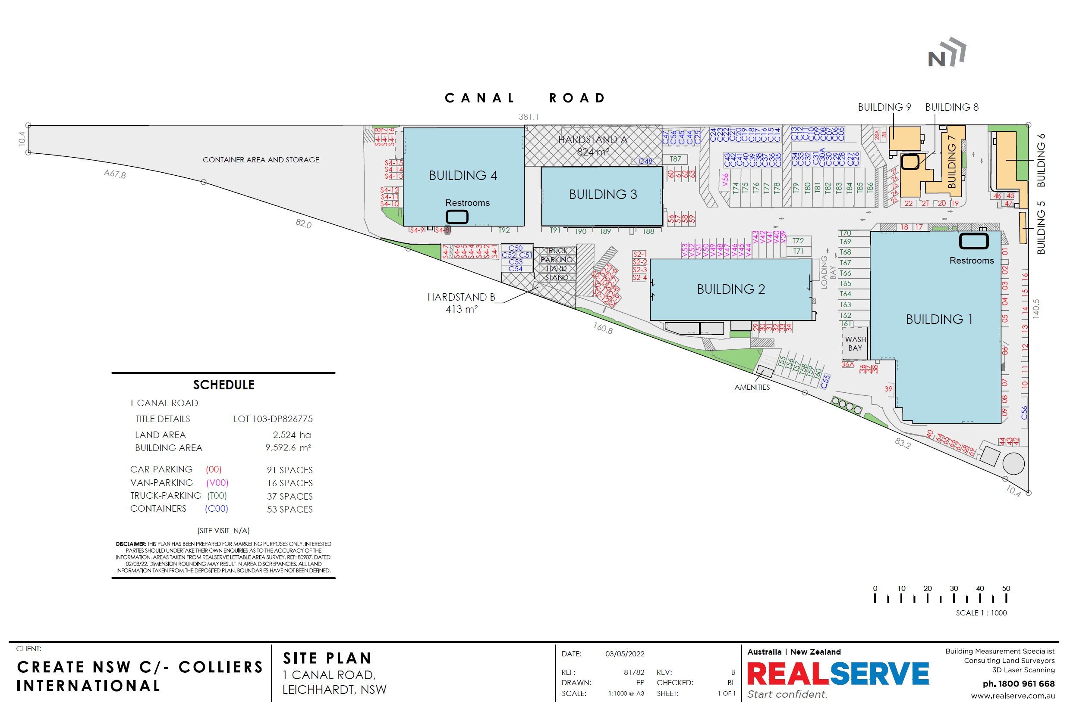
BUILDING 1, unit 1.27
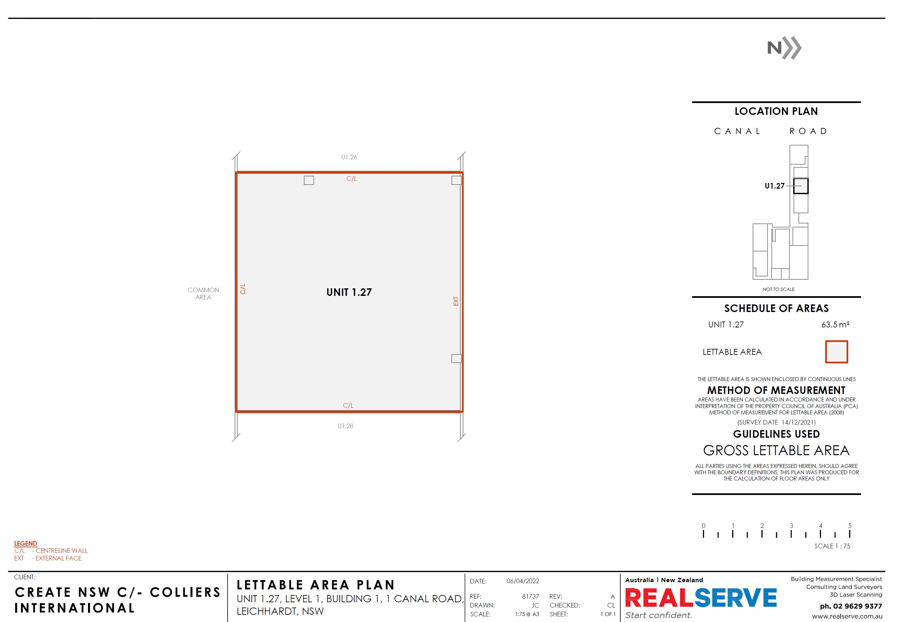

Hardstand parking

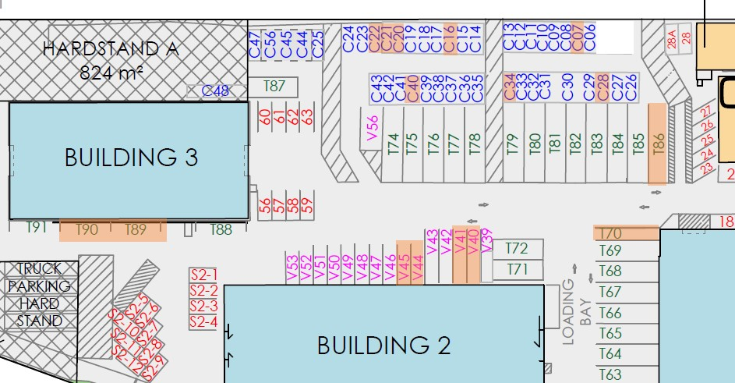

Annexure B

REPAIR, MAINTENANCE AND REPLACEMENT RESPONSIBILITIES
Item | Responsibility of Lessor | Responsibility of Lessee

