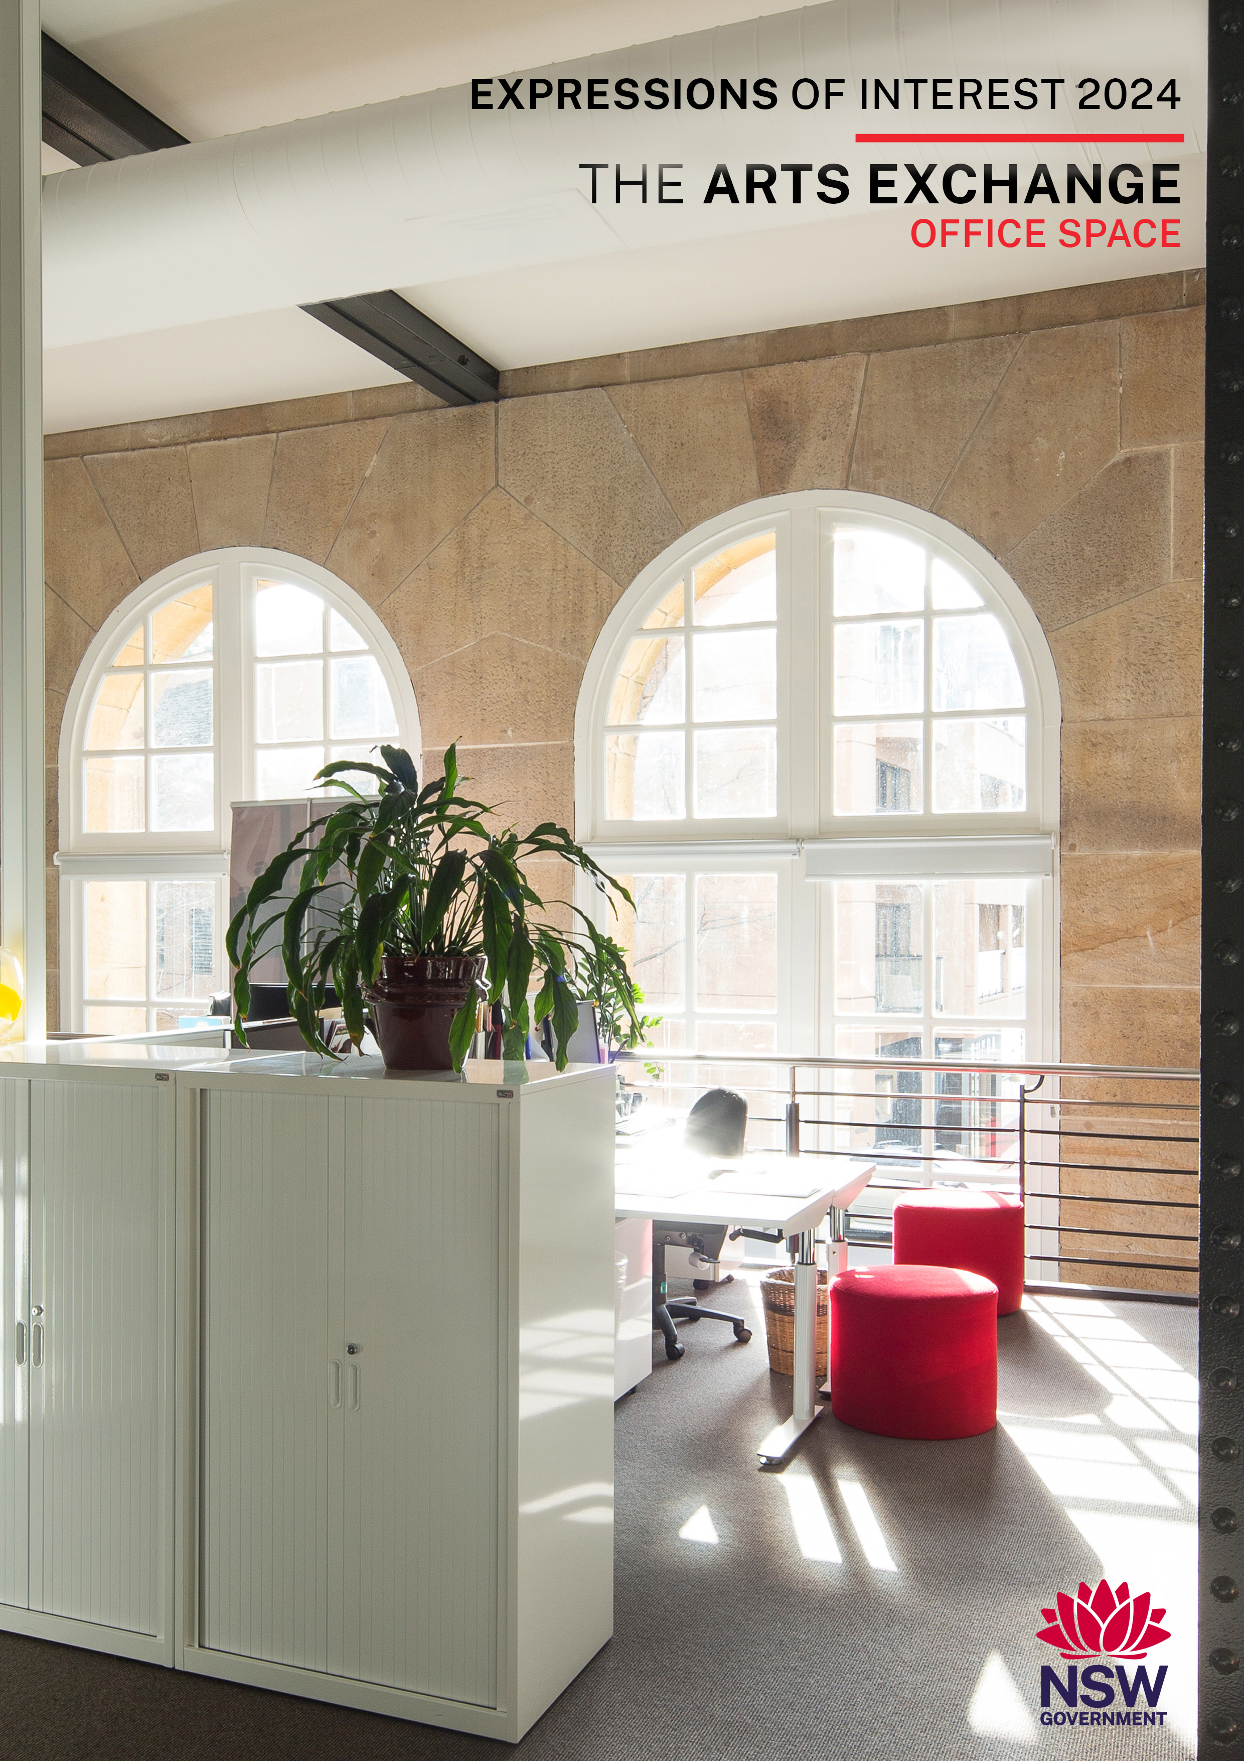

call for Expressions of interest
Create NSW is calling for expressions of interest from eligible arts and cultural organisations to apply for three office spaces within the Arts Exchange building at The Rocks. In applying for this EOI you accept the lease terms and conditions and that a non-negotiable lease agreement based on these terms and conditions will be entered into.

Eoi timeframe
selection process | date
1. Submissions open | 18 October 2024 (3 weeks)
2. Site inspection  Inspection of the office spaces in  person are available by appointment  only. Please contact Greg Eldridge,  Project Manager (Property  Management), Create NSW on (02)  8289 6475 or email  greg.eldridge@create.nsw.gov.au for  details. | By appointment October 2024
3. Closing date for submissions | 10:00am Monday 11 November 2024
3. Notify successful applicants | Late November/early December 2024
4. Notify unsuccessful applicants | Late November/Early December 2024
5. Lease commencement dates | December 2024 or by negotiation

About CREATE nsw and the
infrastructure support policy
Create NSW

Create NSW is the NSW Government’s arts and cultural driver, which brings together arts, screen and culture functions in an integrated entity, and includes cultural infrastructure.
Create NSW is responsible for furthering Government’s vision for NSW to be known for its bold and exciting arts and culture that engages the community, supports innovation, facilitates economic development, and reflects the state’s rich diversity.
Create NSW invests in the success and future of arts, screen and culture in NSW through infrastructure, funding programs, partnerships and advocacy.
Create NSW is committed to growing, empowering and strengthening the arts, screen and culture sectors in NSW, to embed arts in the everyday and deliver new, innovative and exciting arts and cultural services, infrastructure and experiences for the people of NSW.
Create NSW works to achieve the NSW Government’s strategic objectives to develop and sustain the arts, culture and screen sectors, which are built upon the ambitions of excellence, access and strength, and which reflect and support the diverse communities across NSW.
One means by which Create NSW achieves these objectives is through the management of a property portfolio that provides infrastructure support to arts and cultural organisations and allows them to be co-located with other appropriate organisations.
Further information on Create NSW is available on the Create NSW website www.create.nsw.gov.au

Infrastructure Support Policy

The Create NSW infrastructure support program is a key integrated component of the Government’s program of support to the arts.
Create NSW manages ten properties in and around the Sydney CBD. These have effectively developed as arts and cultural hubs through the clustering of like arts and cultural organisations as tenants. Over 100 organisations are supported in subsidised accommodation.
The Create NSW Infrastructure Support Policy (ISP) guides the operation and management of the infrastructure support program.
The ISP sets out the framework for the allocation of spaces and guidelines for the ongoing operation of the Create NSW property portfolio. The ISP provides that eligible arts and cultural organisations pay 30% of the current market rent for office space, paid monthly in advance.

About THE ARTS EXCHANGE BUILDING
Built from 1902-1908 as a power station, The Arts Exchange is a six- storey stone and brick office building located in The Rocks. In 1999, Create NSW took over the lease for the site and converted the building into office accommodation for the arts.
The vision for the Arts Exchange articulated in the ISP is:
“An operations hub for Sydney’s major festivals and key organisations that support the sharing of resources and efficient delivery of services and events.”
The Arts Exchange currently houses:
- The Sydney Festival
- The Sydney Writers’ Festival
- The Australian Ballet
- The Sydney Film Festival
- The Ballet Society
- Biennale of Sydney
- Regional Arts NSW
- Accessible Arts
- Museums and Galleries of NSW
- NSW Aboriginal Culture Heritage and Arts Association
- Manjian Design Works (Commercial)

Key features of The Arts Exchange building include:
- Its location in the Sydney CBD and proximity to public transport
- “Ramp-up” office space is available for hire. This space is primarily designed to accommodate the extra staff and volunteers of the festivals during peak times. The space is hired to others outside festival hiring periods. A licence is issued by Create NSW for hire of ramp up space subject to conditions including licence fee and evidence of relevant current insurance cover including Public Liability Insurance.
- Shared meeting rooms and facilities.
This environment has fostered efficiencies and cooperation such as the sharing of seasonal staff.

vision for the arts exchange building
“An operations hub for Sydney’s major festivals and key organisations that support the sharing of resources and efficient delivery of services and events.

eligibility
The organisation must be located in NSW. Under the Infrastructure Support Policy (ISP) eligible arts and cultural organisations are those that are either a not-for-profit incorporated body or a co-operative or trust, and are legally constituted. Eligibility includes being aligned with the ISP vision for the building. The commercial space is subject to market rental rates.

information about the premises
Item | DetailS
Office spaces and plans | Three (3) office spaces are available to not-for-profit arts and cultural organisations - Suites 0201, 0305 and 0404. Floor Plans of the available office spaces are shown at Annexure A.
Infrastructure Support Policy - not for-profit entities | Under the Create NSW Infrastructure Support Policy eligible not-for-profit arts and cultural organisations pay 30% of current market rent for office space. Rent is paid monthly in advance and adjusted annually by CPI. A market rent assessment is undertaken every 5 years. If a lease is on holdover for more than 12 months rent will increase by the CPI.
Office fit-out | Existing desks will be supplied to not-for-profit tenants. Tenants will need to purchase other standard furniture (shelves and chairs) to comply with the building’s image.
Parking | There are no parking facilities associated with the building. There is limited metered on street public parking.
Shared Facilities | - Shared kitchen and meeting room(s) are provided on each floor (Ground Floor and Levels 1-4).  - Shared meeting rooms and kitchen on the Ground Floor (3 meeting rooms; 2 x 8 people meeting rooms - the partition between these rooms can be opened up to create a large meeting room) and another 1 x 16 people meeting room).  - Bicycle storage room on the Ground Floor and end of trip facilities.  - Shared storeroom space by negotiation.  - First aid room/breastfeeding room Ground Floor
Ramp-Up Space | ‘Ramp-up’ office space is available for hire.  This additional office space is primarily designed to accommodate the ramp up and ramp down activity of the work of the festivals during festival time. When not being used by the festivals, the space is hired on a weekly basis.

KEY LEASE terms

Item | DetailS
Lease term | Five (5) years.
Tenancy Floor Plans | Floor Plans are at Annexure A of this document. Relevant floor plans will form part of the leases granted to successful EOI applicants.
Rent and estimated Outgoings | Rent  The Create NSW Infrastructure Support Policy (ISP) provides that eligible not-for profit arts and cultural organisations pay 30% of current market rent. Current ISP subsidised office rent rates at the Arts Exchange for the three available office suites is $213.00 per square metre per annum for Suite 0201 (harbour side) and $192.85 per square metre per annum for Suites 0305 and 0404 (George Street side). A higher rate applies for Suite 0201 due to suite location/aspect (harbour side). Current office market rent for the three available suites is: $710.00 per square metre per annum (Suite 0201) and $642.84 per square metre per annum (Suites 0305 and 0404). Rent is paid monthly in advance and adjusted annually by CPI.  A market rent assessment is undertaken every 5 years. If a lease is on holdover for more than 12 months rent will increase by the CPI.  Outgoings  Tenants pay tenancy outgoings.  Tenants will also be required to contribute to the building’s outgoings and common area cleaning based on the percentage of the area occupied by the tenant. Currently estimated at around $232.15 per square metre per annum paid monthly in advance and adjusted annually. The lettable area of the Arts Exchange is 1753.35 square metres.
Suite No. | Floor | Area m2 | Rent $/month* | Estimated Outgoings $/month*
0201 | 2 | 37.07 | $657.99 | $717.15
0305 | 3 | 42.41 | $681.56 | $815.43
0404 | 4 | 53.15 | $854.16 | $1,020.23
*Excludes GST. Paid monthly in advance and adjusted annually each financial year.
Office fit-out | Existing desks are supplied to not-for-profit tenants. Tenants will need to purchase other standard furniture (shelves and chairs), to comply with the building’s image.
Repair, maintenance and replacement responsibilities | Responsibility for repair, maintenance and replacement is split between the Lessor and Lessee. The Lessor is responsible mainly for building fabric and the Lessee for fixtures and fittings and tenancy items.  Details of the repair, maintenance and replacement responsibilities are shown in Annexure B.  NSW Heritage legislation may apply given the heritage listing of the Arts Exchange.
Work Health and Safety | The Lessee will be required to comply with all relevant provisions of the Work Health and Safety Act 2011.
Law | The Lessee will be required to comply with all applicable Law.
Insurance | The Lessee will be required to provide evidence of current public liability insurance in an amount of not less than $20m.
Indemnity | Leases granted to successful EOI applicants will include an Indemnity clause:  The Lessee uses the Leased Area and the Site at its own risk, and the NSW Government (represented by Create NSW) and its employees, agents and contractors are released from (and The Lessee indemnifies them against) any liability and responsibility for any loss, cost, damage, injury, liability or death that may be sustained or suffered by the NSW Government arising out of or in connection with, amongst other things:  1. the access to or use of the Leased Area or the Site; or  2. any act, omission, default, misconduct, or breach of law,  caused or contributed to by the Lessee or the Lessee’s authorised persons (including employees, agents, servants, sub-contractors, contributors, participants, performers, artists, or guests of The Lessee), except to the extent caused or contributed to by NSW Government (represented by Create NSW) and its employees, agents and contractors.
Termination | The Lessor may give notice of termination at any time to the Lessee by notice in writing. The date of termination will be not less than 12 months from the date of service of a termination notice.
Assignment and subletting | The Lessor shall not assign its interest in any sublease granted or mortgage or assign its interest without the prior written consent of the Lessor.
Lessor’s right to enter | The Lessor will allow the Lessor to enter the tenancy during the term of any sublease to view the tenancy and carry out repairs, renovations and maintenance.
Head lease | The Lessee will be required:  - to acknowledge that it has reviewed and is fully aware of the provisions of the Headlease  - during the term of any sublease granted or holdover not to do or allow any act matter or thing to to be done that will be a breach of the provisions of the Headlease having application to the terms of any sublease granted.

Successful EOI applicants will receive a non-negotiable lease giving effect to the above terms for the relevant space/s.

selection criteria
EOI will be considered by an evaluation committee chaired by Create NSW, including an independent member and a probity advisor, based on the following criteria.
1 | Alignment with the Create NSW Infrastructure Support Policy’s Vision for The Arts Exchange and the ability to support the objectives of the building.  The not-for-profit organisation appliacants will need to demonstrtae alignmnet withy the building’s vision:  Vision  “An operations hub for Sydney’s major festivals and key organisations that supports sharing of resources and efficient delivery of services and events.”  All applicants, as part of addressing this selection criteria, need to:  - outline the benefits to your organisation of being located at The Arts Exchange  - outline the co-location benefits the organisation could bring to The Arts Exchange, and  - detail the organisation’s planned use of the premises and outline planned utilisation levels.
2 | Quality and Reach  Organisation’s contribution to the arts and cultural sector  Describe how the organisation delivers on at least one of the following objectives to:  - deliver a dynamic and diverse range of arts and cultural experiences to communities across NSW  - contribute to the development of a vibrant and accessible arts and cultural sector, or  - support the employment and development of professional NSW-based artists and arts and cultural workers.
3 | Governance and Finance  Be a well governed, financially sustainable not-for-profit arts organisation.  As part of addressing this selection criteria organisations will need to provide:  - Evidence from the Australian Charities and Not-for-profits Commission that the organisation is registered as a charity and that its reporting is up to date.  - Organisational profile, brief history and outline objectives.  - Profiles of Key Management Staff (name, position, primary objectives, experience)  - Overview of the organisation’s financial profile over the last five years, including the source and extent of Government funding (including from Create NSW), private sector support and self-generated funding.  - The last 5 years of either:  - Audited financial statements (if required to audit) or  - Balance sheets and profit and loss statement signed by the head of the organisation (if not required by law to audit).  - Business references from landlords over the past 5 years.
4 | Do you currently have other subsidised rental spaces in Create NSW properties?  In addressing this criteria please respond Yes/No  and also advise:  If Yes, please specify which type of space: office/creative or storage/workshop.
5 | Was your total annual turnover less than $50m in Financial Year 2022-2023/Financial Year ending 31 December 2023?  In adressing this criteria please respond Yes/No

Shortlisted potential tenants may be invited for further discussion with Create NSW. An invitation to participate in these discussions will not constitute a commitment by Create NSW.

SITE inspection
Inspection of the office spaces in person are available by appointment only.
Please contact Greg Eldridge, Project Manager (Property Management), Create NSW on (02) 8289 6475 or email greg.eldridge@create.nsw.gov.au for details.

Submission of EOI
EOIs need to be submitted through the online form in Smarty Grants (https://artsnsw.smartygrants.com.au/2024ArtsExchange) before 10:00am on Monday 11 November 2024.
No late EOIs will be accepted.
The issue of this EOI does not commit or otherwise oblige Create NSW or the Department of Creative Industries, Tourism, Hospitality and Sport (Department) to proceed with any part of the steps of this EOI process, including for the avoidance of doubt the entry into a sublease with any applicant.
Neither Create NSW nor the Department will be liable for the applicant’s costs of submitting the EOI or any other liability of the applicant arising out of the EOI not proceeding or the applicant being unsuccessful.
Whilst the information contained in this EOI has been formulated with all due care, neither Create NSW nor the Department warrant or represent that the information is free from errors or omissions. The information is made available on the understanding that the Department and its respective employees and agents, shall have no liability (including liability by reason of negligence) for any loss, damage, cost or expense incurred or arising by reason of any person using or relying on the information and whether caused by reason of any error, omission or misrepresentation in the information or otherwise.
Furthermore, neither Create NSW nor the Department take any responsibility for the accuracy, currency, reliability and correctness of any information included in this EOI.
The decision to grant a sublease to an applicant is at the sole discretion of the Department, acting through Create NSW. No legally binding agreement will be created between the Crown in right of the State of New South Wales (acting through the Department of Creative Industries, Tourism, Hospitality and Sport (Create NSW) and an applicant unless and until a sublease is signed by the parties.

Further information | Greg Eldridge, Project Manager (Property Management), Create Infrastructure, Create NSW  Telephone: (02) 8289 6475  Email: greg.eldridge@create.nsw.gov.au

Annexure A

SUITE Floor Plans

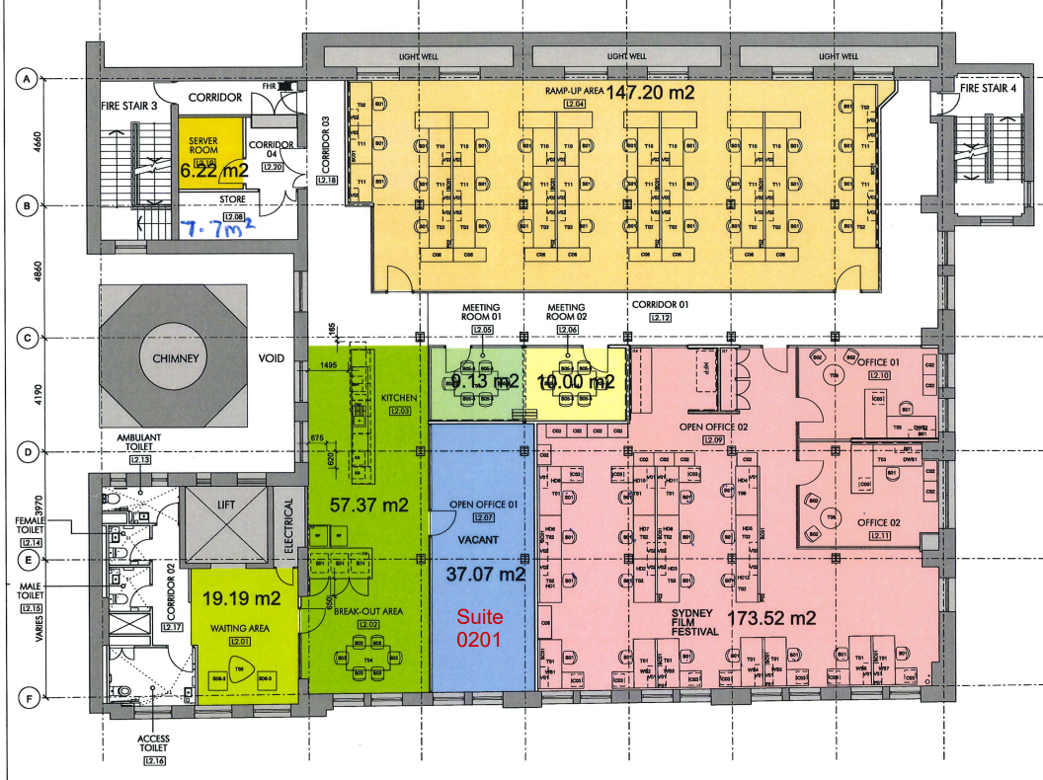
Floor plan Level 2

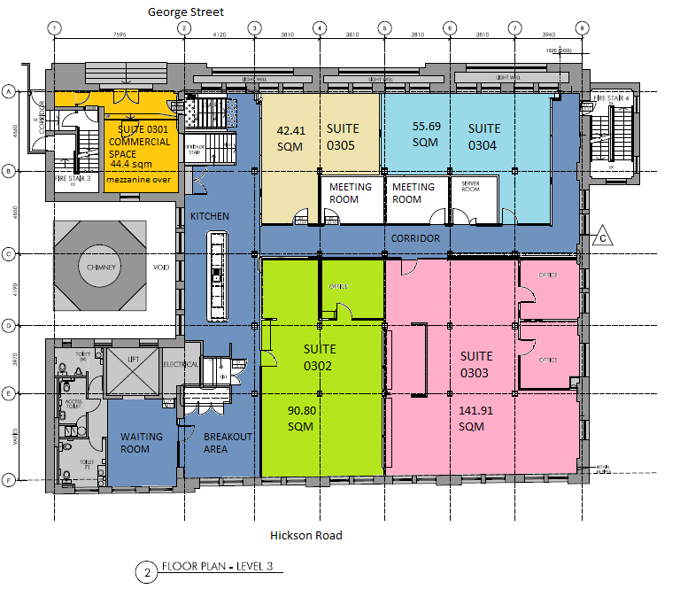

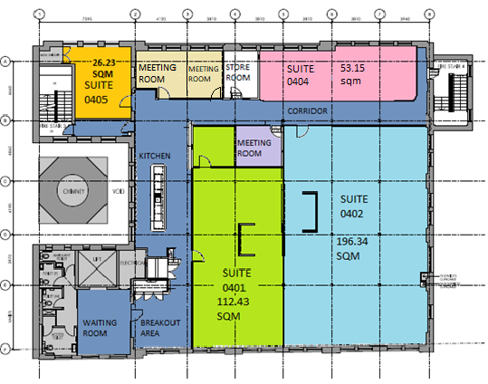
FLOOR PLAN – LEVEL 4

Annexure B

REPAIR, MAINTENANCE AND REPLACEMENT RESPONSIBILITIES
Item | Responsibility of Lessor | Responsibility of Lessee

