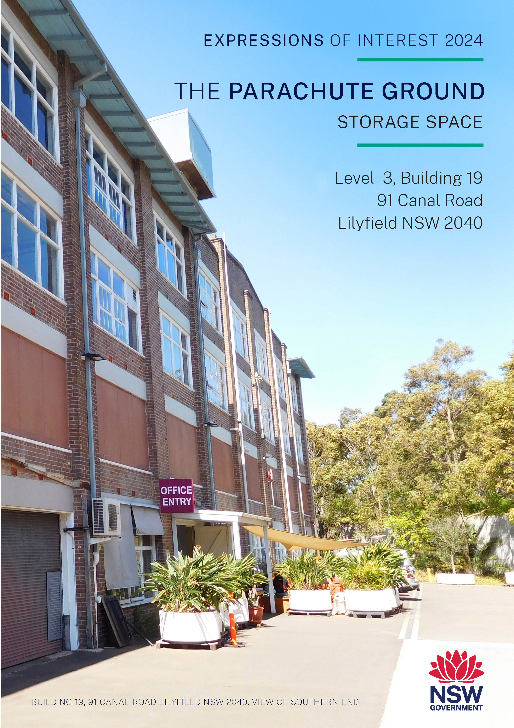

call for Expressions of interest
Create NSW is calling for expressions of interest (EOI) from eligible arts and cultural organisations to occupy one (1) storage space (area 242m² as shown on the floor plan at Annexure A) at The Parachute Ground, Level 3, Building 19, 91 Canal Road, Lilyfield NSW 2040 for a period of 5 years commencing on 18 October 2024 (3 weeks). In applying for this EOI you accept the licence terms and conditions and that a non-negotiable licence agreement based on these terms and conditions will be entered into.

Eoi timeframe
selection process | date
1. Site Inspection | 10:00am 25 October 2024
2. Closing Date for EOI submissions | 10:00 am 11 November 2024
3. Notify successful applicant | Late November/Early December 2024
4. Notify unsuccessful applicants | Late November/Early December 2024
5. Licence commences | December 2024 or by negotiation

About CREATE nsw and the
infrastructure support policy
Create NSW

Create NSW is the NSW Government’s arts and cultural driver, which brings together arts, screen and culture functions in an integrated entity, and includes cultural infrastructure.
Create NSW is responsible for furthering Government’s vision for NSW to be known for its bold and exciting arts and culture that engages the community, supports innovation, facilitates economic development, and reflects the state’s rich diversity.
Create NSW invests in the success and future of arts, screen and culture in NSW through infrastructure, funding programs, partnerships and advocacy.
Create NSW is committed to growing, empowering and strengthening the arts, screen and culture sectors in NSW, to embed arts in the everyday and deliver new, innovative and exciting arts and cultural services, infrastructure and experiences for the people of NSW.
Create NSW works to achieve the NSW Government’s strategic objectives to develop and sustain the arts, culture and screen sectors, which are built upon the ambitions of excellence, access and strength, and which reflect and support the diverse communities across NSW.
One means by which Create NSW achieves these objectives is through the management of a property portfolio that provides infrastructure support to arts and cultural organisations and allows them to be co-located with other appropriate organisations.
Further information on Create NSW is available on the Create NSW website www.create.nsw.gov.au

Infrastructure Support Policy

The Create NSW infrastructure support program is a key integrated component of the Government’s program of support to the arts.
Create NSW manages nine properties in and around the Sydney CBD. These have effectively developed as arts and cultural hubs through the clustering of like arts and cultural organisations as tenants. Over 100 organisations are supported in subsidised accommodation.
The Create NSW Infrastructure Support Policy (ISP) guides the operation and management of the infrastructure support program.
The ISP sets out the framework for the allocation of spaces and guidelines for the ongoing operation of the Create NSW property portfolio. The ISP provides that eligible arts and cultural organisations pay 50% of the current market rent for storage, paid monthly in advance.

About the PARACHUTE GROUND
The Parachute Ground is a former Army parachute regiment store. The site comprises of three main buildings (1, 5, and B19) and a purpose-built physical theatre rehearsal facility “Red Box”. The site is part of the Canal Road Arts Precinct and supports 25 arts organisations and cultural institutions.
BUILDING 19
Building 19 is a four-level building of brick and masonry construction with concrete floors and a roof supported by timber trusses. Timber columns supporting the roof are spaced approximately every 6m.

The storage space available is shown in Annexure A, and as follows:

Level 3 – storage cage
One (1) storage cage space (steel chain mesh fencing 2480mm high) in the middle section of Level 3, Building 19 is available, with an area of:
- Space 3.6: 242m²

There are windows on the eastern side of the storage cage.

Access to the cage is via the main lift and a double chain mess steel gates (each 1000mm wide) from the common area on the western side of the storage cages through lockable chain mesh double gates.

Floor loads
Floor loading capacity ranges between 3kPa to 5kPa (300kg/m² to 500kg/m². Floor load plans and sample layout diagrams are provided at Annexure B.

Lift access and security
Access to Level 3, Building 19 is available via two goods lifts from two separate Ground Floor lift lobbies on the western side of Building 19.

Access to the lift lobbies and the lifts to the Level 3 storage area requires a security swipe card. Swipe cards (2) will be provided to the successful EOI applicant. Additional swipe cards will be provided at cost.

Keys to the tenancy space on Level 3 will also be provided to successful EOI applicant.

Lift dimensions and load capacities
LIFT 2 LIFT 3
Door span: Door span:
1900mm wide X 2200mm high 1500mm wide X 2200mm high
Load capacity: 4,100kg Load capacity: 3,128kg

Fire system
A fire sprinkler system is installed.

Amenities
Male and female toilets, an accessible toilet and a shared kitchen with dishwasher and refrigerator are located on Level 3.

vision for The PARACHUTE GROUND
“An ‘engine room’ for the small to medium sized arts sector that supports creative development and incubation of ideas. The site complements presentation facilities at Carriageworks and the Walsh Bay Arts Precinct and leverages existing creative activity in the surrounding area. The site also supports limited active storage for the sector.”

eligibility
Under the Infrastructure Support Policy eligible arts and cultural organisations are those that are either a not-for-profit incorporated body or a co-operative or trust, and are legally constituted.

information about the premises, lICENCE term and LICENCE FEE
Item | Detail
Licence term | 5 years
Tenancy | Level 3 Building 19  One (1) storage cage space:  - Space 3.6 242m²  Notes:  - EOI submissions for storage space of less than the area of the space are acceptable. However, partitioning costs will be at the cost of successful applicant/s  - EOI responses will need to provide details of the types of items proposed to be stored.
Licence fee | Under the Infrastructure Support Policy (ISP) eligible arts and cultural organisations pay 50% of market rent for storage, paid monthly in advance. The fee is adjusted annually by movements in the Consumer Price Index (CPI).  Market rent is $160 m² pa plus GST.  ISP rent rate is $160 m² pa plus GST X 50% = $80 m² pa plus GST  Level 3 Building 19  One (1) storage space (ISP rent rate $80 m² pa plus GST):  - Space 3.6: 242m² - Licence fee = $19,360 pa plus GST
Outgoings | Tenants will be required to contribute to the site’s common area outgoings and common area cleaning, based on the percentage of the site’s Nett Lettable Area occupied by the tenant.  Common area outgoings are currently $20.28 pa plus GST per m²  Tenants will be responsible for all internal tenancy outgoings, such as metered electricity consumption.
Parking | Shared car parking spaces are available but no dedicated car spaces are associated with the premises. There is also limited on street public parking.
Shared Facilities | Shared kitchen and toilets on Level 3.
Total Estimated rent and common area outgoings costs for the available space | Level 3, Building 19  One (1) storage space (ISP rent rate $80 m² pa plus GST)  Space 3.6: 242m²  - Licence fee $19,360.00 pa plus GST  - Contribution to $ 4,907.76 pa plus GST  site outgoings/common  area cleaning  Total $24,267.76 pa plus GST  A security deposit in an amount of three-month’s rent ($4,439.99) will be required to be lodged by the successful EOI proponent.

Successful EOI applicants will receive a non-negotiable licence giving effect to the above terms for the relevant space/s.

selection criteria
EOI will be considered by an assessment committee chaired by Create NSW based on the following criteria.
1 | Alignment with the Create NSW Infrastructure Support Policy’s Vision for Lilyfield and the ability to support the objectives of the site.  Vision  “An ‘engine room’ for the small to medium sector that supports creative development and incubation of ideas. The site complements presentation facilities at Carriageworks and the Walsh Bay Arts Precinct and leverages existing creative activity in the surrounding area. The site also supports limited active storage for the sector.”  As part of addressing this selection criteria, applicants will need to:  - Outline the benefits your organisation could bring to Lilyfield with regard to the Vision, and  - Outline the benefits that being a tenant at Lilyfield will bring to your organisation.
2 | Quality and Reach  Organisation’s contribution to the arts and cultural sector  Describe how the organisation delivers on at least one of the following objectives to:  - deliver a dynamic and diverse range of arts and cultural experiences to communities across NSW  - contribute to the development of a vibrant and accessible arts and cultural sector, or  - support the employment and development of professional NSW-based artists and arts and cultural workers.
3 | Be a well governed, financially sustainable not-for-profit arts organisation  As part of addressing this selection criteria organisations will need to provide:  - Evidence from the Australian Charities and Not-for-profits Commission that the organisation is registered as a charity and that its reporting is up to date.  - Organisational profile, brief history and outline objectives.  - Profiles of Key Management Staff (name, position, primary objectives, experience)  - Overview of the organisation’s financial profile over the last five years, including the source and extent of Government funding (including from Create NSW), private sector support and self-generated funding.  - The last 5 years of either:  - Audited financial statements (if required to audit) or  - Balance sheets and profit and loss statement signed by the head of the organisation (if not required by law to audit).  - Business references from landlords over the past 5 years.
4 | Do you currently have other subsidised rental spaces in Create NSW properties?  In addressing this criteria please respond Yes/No  and also advise:  Does this include storage space? Yes/No
5 | Was your total annual turnover less than $50m in Financial Year 2022-2023/Financial Year ending 31 December 2023?  In adressing this criteria please respond Yes/No
Shortlisted potential tenants may be invited for further discussion with Create NSW. An invitation to participate in these discussions will not constitute a commitment by Create NSW.

SITE inspection
Inspection of the storage space will be by appointment only.
Please contact Subash Gurram, Create NSW on 0451 0750294 or email Subash.gurram@create.nsw.gov.au for details.

Submission of EOI
EOIs need to be submitted through the online form in Smarty Grants (https://artsnsw.smartygrants.com.au/2024Lilyfield) before 11:00 am 11 November 2024

No late EOIs will be accepted.
Further information  and Site Inspection APPOINTMENTs | Subash Gurram, Precinct Operations Manager (Property Management),  Create Infrastructure, Create NSW  Telephone: 0451 075 294  Email: subash.gurram@create.nsw.gov.au

Annexure A

Floor Plans

Level 3 Building 19, 91 Canal Road, LILYFIELD NSW 2040

One (1) storage cage space:
- Space 3.6 (S3.6) 242m²

Grey shaded area – common area access to lifts

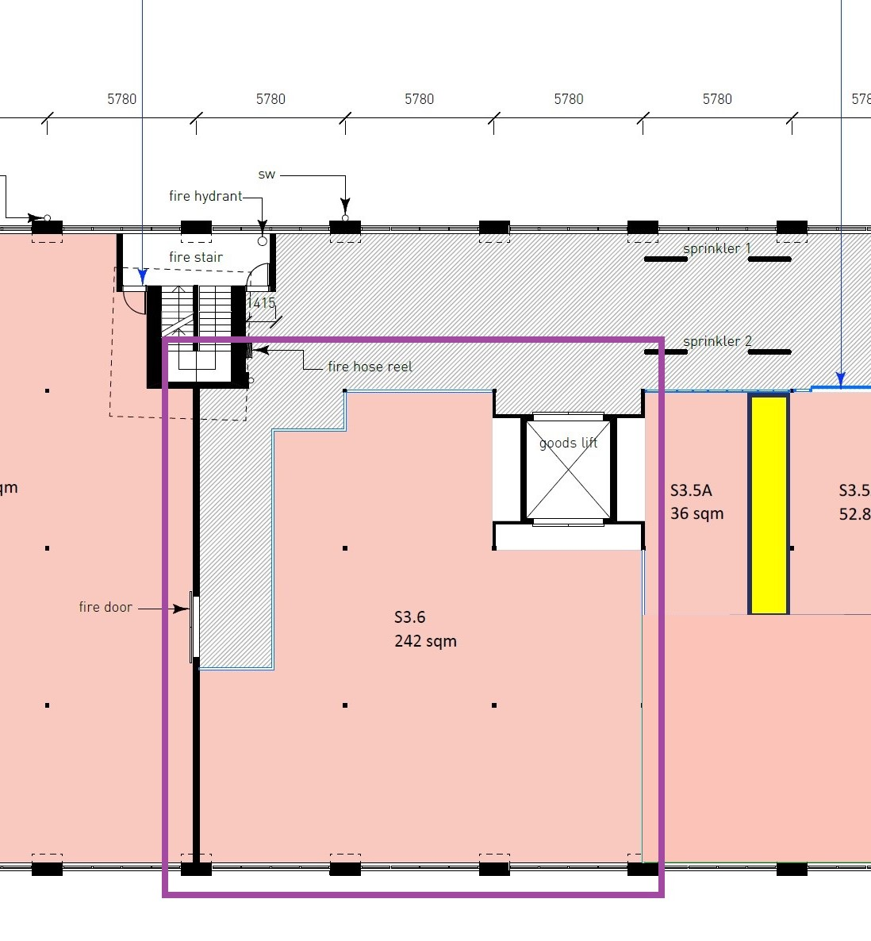

Annexure B

Floor LOAD LIMITS

Level 3, Building 19, 91 Canal Road, LILYFIELD NSW 2040

